**RenderMonkey ACW Report  
Texture Mapped Kitchen Environment**  
The kitchen environment is textured mapped using 2D textures. The textured is blended with the colour.  
**Vertex Shader Excerpt:**  
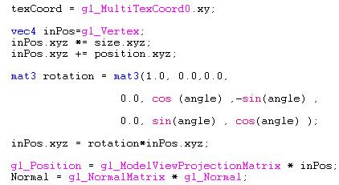  
**Fragment Shader Excerpt:**  
kitchenenvironmentFragment.JPG  
**Effect Screenshot:**  
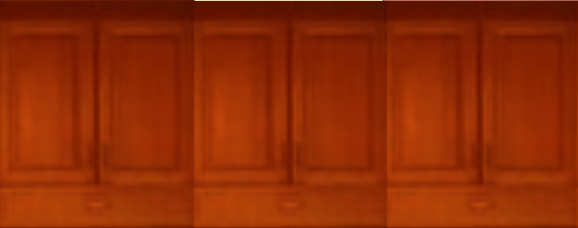**Shiny Teapot Rendered Using A Cube Mapping Technique, Which Reflects The Kitchen Environment**I created a cubemap of my kitchen environment using ATI’s CubeMap Generator and made the teapot reflect this, so it became a shiny teapot. **Vertex Shader Excerpt:  
shinyTeapotVertex.JPG  
Fragment Shader Excerpt:  
shinyTeapotFragment.JPG  
Effect Screenshot:**

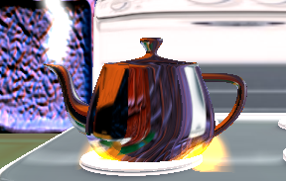  
**Bumpy Brick-walls Around the Cooker Rendered with BumpMapping Techniques**I made the walls behind the cooker and to the left and right of the cooker appear ‘bumpy’ using a bump mapping technique, when infact the walls are flat.  
**Vertex Shader Excerpt:  
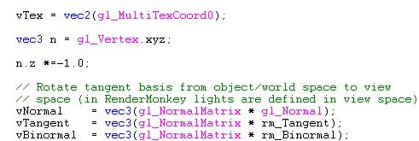  
Fragment Shader Excerpt:  
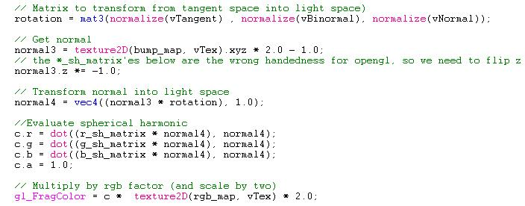Effect Screenshot:  
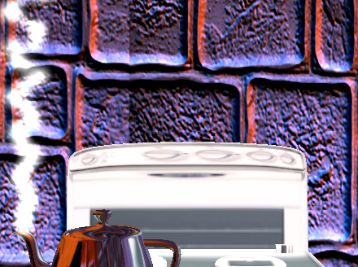  
Animated Cooker-fire and Steam Emitted From the Rim of the Teapot.**I rendered the steam and fire effects using particle systems. **Vertex Shader Excerpt:  
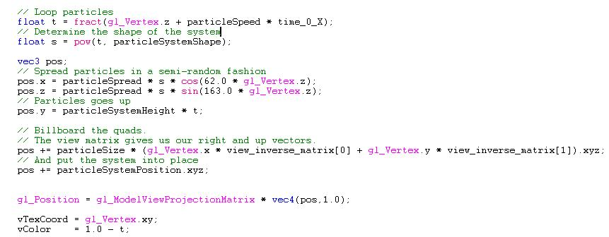  
Fragment Shader Excerpt:  
steamFireFragmentJPG.JPG  
Effect Screenshot:  
  
Spot-Light Sources to Illuminate the Kitchen.**I implemented two spot-light sources using a per-pixel approach because it looks better than a per-vertex approach. **Vertex Shader Excerpt:  
lightVertex.JPG  
Fragment Shader Excerpt:  
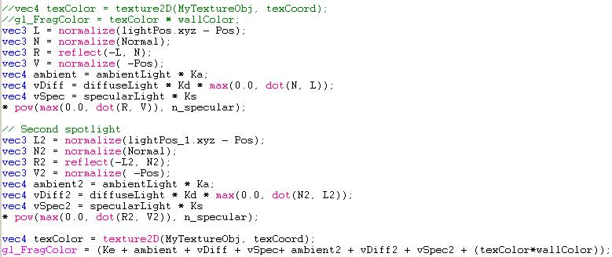Effect Screenshot:  
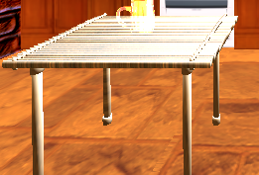  
Kitchen Facility Models**I implemented, a kitchen cooker, kitchen table, and kitchen sink models. **Vertex Shader Excerpt:  
lightVertex.JPG  
Fragment Shader Excerpt:  
Effect Screenshot:  
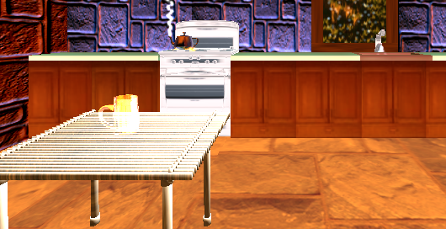  
Animated Water in the Kitchen Sink**I animated the water by making the textures co-ordinates move according to a time variable. **Vertex Shader Excerpt:  
animatedWaterVertex.JPG  
Fragment Shader Excerpt:  
animatedWaterFragment.JPGEffect Screenshot:  
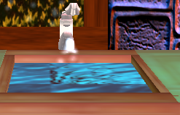  
  
Novel Effects  
Opaque Empty Beer Glass**The empty beer glass refracts and reflects a cubemap I created of the kitchen environment so that the empty beer glass becomes opaque.  
**Vertex Shader Excerpt  
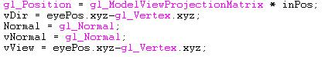  
Fragment Shader Excerpt  
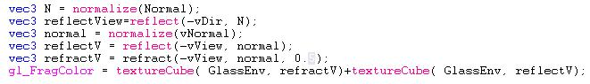Effect Screenshot  
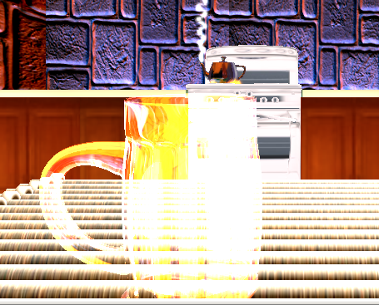  
Water From the Tap**I used a particle system effect to create water that comes from the kitchen tap. **Vertex Shader Excerpt  
Fragment Shader Excerpt  
steamFireFragmentJPG.JPG  
Effect Screenshot  
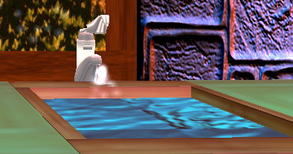  
Snow Through the Window**To create the snow through the window I used a particle effect system. **Vertex Shader Excerpt  
Fragment Shader Excerpt  
steamFireFragmentJPG.JPG  
Effect Screenshot  
